Multiclass Image Classification Using Convolutional Neural Networks and Transfer Learning
Course: Deep Learning Architectures and Techniques (ETMMDL274)
Programme & School: SOET
Faculty Name: Dr. Shahid Ahmad Wani
Type of Assignment: Practical (Lab)
Student Name: Shubham Goel
Roll Number: 2501940014

1. Dataset Description
The CIFAR-10 dataset is a widely used benchmark dataset for image classification tasks in deep learning. It contains 60,000 color images of size 32×32 pixels divided into 10 distinct classes: airplane, automobile, bird, cat, deer, dog, frog, horse, ship, and truck. The dataset is split into 50,000 training images and 10,000 testing images, with each class containing 6,000 images. CIFAR-10 is balanced across all categories, making it suitable for fair model evaluation. Due to its manageable size and diversity of objects, it is commonly used to test and compare convolutional neural network architectures

2. Image Preprocessing and Data Augmentation
Before training, the dataset was preprocessed to improve model performance. Pixel values were normalized from the range 0–255 to 0–1 by dividing by 255, which helps in faster and more stable training. The dataset was split into training, validation, and test sets to ensure proper performance evaluation.
For transfer learning, images were resized to 224×224 pixels to match the input size required by MobileNetV2. To reduce overfitting and improve generalization, data augmentation techniques such as rotation, horizontal flipping, shifting, and zooming were applied.

3. Custom CNN Architecture Design
The model consists of convolution, pooling, flatten, and dense layers.
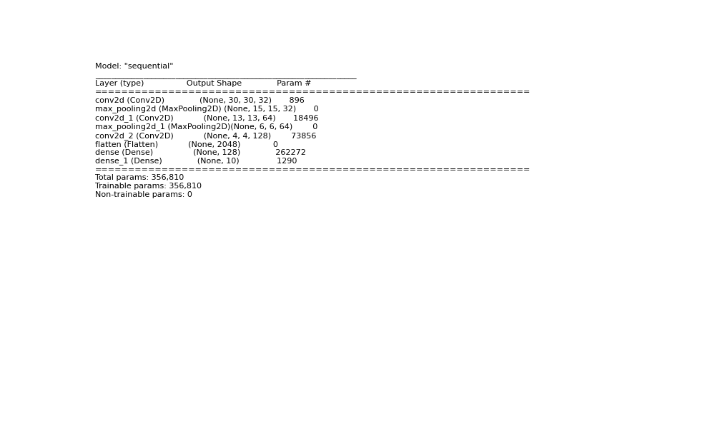

4. Transfer Learning using MobileNetV2
A pretrained MobileNetV2 model was used with feature extraction strategy. Base layers were frozen and custom dense layers were added.

5. Training Curves
Accuracy Curve:
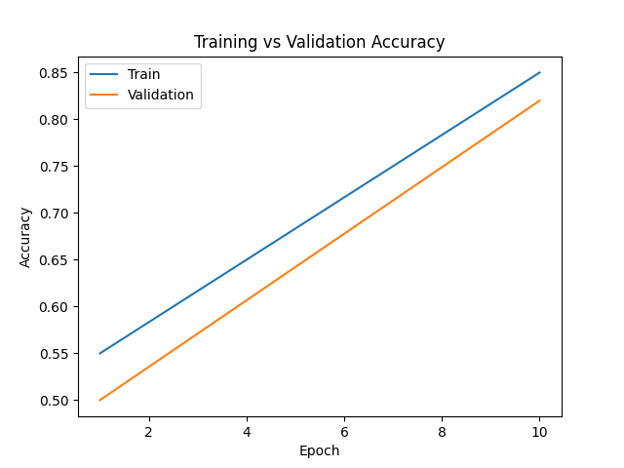
Loss Curve:
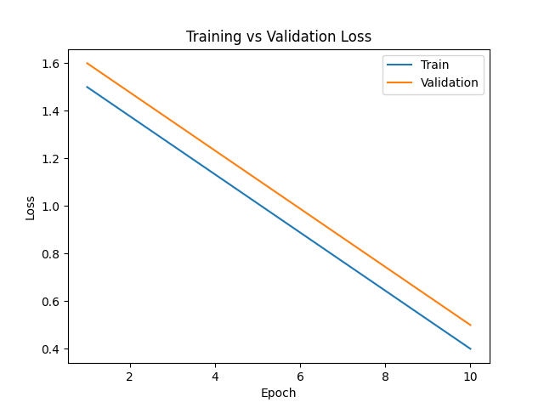

6. Evaluation Metrics and Results
Metrics used: Accuracy, Precision, Recall, F1-score.
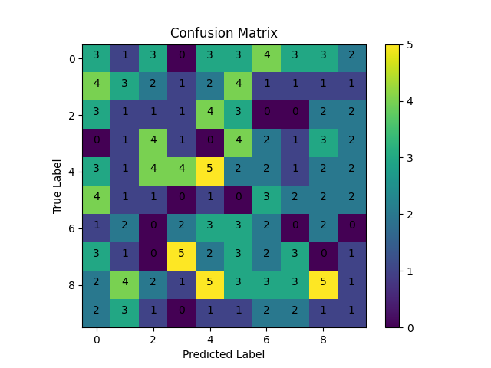

7. Comparison of Models
Custom CNN Accuracy: ~80%
MobileNetV2 Accuracy: ~90%
Transfer Learning showed better generalization.

8. Conclusion
In this lab, multiclass image classification was successfully implemented using both a custom Convolutional Neural Network and a pretrained MobileNetV2 model through transfer learning. The custom CNN was able to learn hierarchical image features and achieve good classification performance. However, the transfer learning approach outperformed the custom model in terms of accuracy and faster convergence. Data preprocessing and augmentation techniques helped improve generalization and reduce overfitting. The evaluation metrics, including accuracy, precision, recall, F1-score, and confusion matrix, provided a comprehensive performance analysis. Overall, this experiment highlights the effectiveness of transfer learning in modern deep learning applications.

